Software Requirements Specification

for

Hotel Reservation System Version 1.1

Prepared by  
A H Vihidu Siththaru De Silva

|  |  |
| --- | --- |
| Date: | 19/07/2021 |

Contents

Introduction 01

Document Purpose 01

Product Scope 01

Definitions, Acronyms and Abbreviations 02

Overall Description 03

Product Perspective 03

Software Interfaces 04

Hardware Interfaces 04

User Characteristics 05

Design and Implementation Constraints 06

Assumptions and Dependencies 07

Architecture Design…………………………………………………………………………………………………………………………07

Use Case Diagrams, Model Descriptions & Use Case Reports………………………………….………………….07

Class Diagram……………………………………………………………………………………………………………………………..14

Sequence Diagrams…………………………………………………………………………………………………………………….14

ER Diagram………………………………………………………………………………………………………………………………….18

Over roll documentation and Specific Requirements………………………………………………………………………19

Supplementary Requirements…………………………………………………………………………………………………….19

User Interfaces……………………………………………………………………………………………………………………………20

# 

# Introduction

## Document Purpose

The System Requirements Specifications (SRS) document's following subsections provide a description of the whole SRS. The Pharmacy Management System's (PMS), SRS will include a comprehensive overview of the system's requirements. This SRS will have a detailed understanding of what can be expected from the pharmacy management system that will be designed. The right applications for the end user will be created using the simple interpretation of the pharmacy management system and its capabilities, which will be used for the advancement of the project's future phases. This SRS will act as the project's base. The pharmacy management system can be programmed, installed, and finally tested using this SRS.

The tech engineering created the pharmacy management system and all the pharmacy's end users can use this SRS. The SRS will be used by the software developers to completely comprehend the owner’s demands in order to build the required software. End users of the pharmacy will be able to use this SRS to see how the tech developers are designing the device according to their requirements. If it does not meet their standards, the end users should explain why, and the software developers can modify the SRS to meet their requirements.

## Product Scope

The pharmacy's main operations will be automated by launching this software. The first subsystem is an order and product handling system to keep track of orders and products availability. The second subsystem is the general service offered by pharmacy i.e.; special offers, customer care and other services. In the third subsystem, the system will generate reports. The administration unit (or receptionist) will keep an eye on it. There are two end users for this system. Customers and pharmacy administrators are the end users (Admin and Employees). The ordering, buying and product viewing system, as well as the products monitoring and sale system, are accessible to all types of users. Some authorities are only open to customers. The owner has unrestricted access to all of the system's features. With a few exceptions, the owner has direct access to all device functions. Accordingly, the receptionist will only have access to the orders and payments. This system will build different Login functions to keep restrictions for each End User level. The automated pharmacy management system's aim is to make the pharmacy's day-to-day operations easier. The system would be able to manage a range of services in order to offer timely service to all customers. Some of the advantages include safety, security, ease of use, and, most importantly, the efficiency of information retrieval.

## Definitions, Acronyms and Abbreviations

|  |  |
| --- | --- |
| SRS | Software Requirement Specifications |
| PMS | Pharmacy Management System |
| GRN | Good Receive Note |
| DBMS | Database Management System |
| OS | Operating System |
| DB | Database |
| End users | The people who use the system |
| Subjective Satisfaction | The overall software satisfaction |

# Overall Description

## Product Perspective

Simply, this system has the ability to provide customers with easy and trust worthy way of purchasing products online. The PMS is a new self-contained software product. These systems can have a variety of problems. There are times when it is difficult to identify what those problems are. Therefore, by using a manual to the system, we can solve the problems that may arise. Also, if you are planning to introduce a new system, it should be easy for the user to handle. The interfaces of the system should be considered carefully. The system also provides the client with better options for calculations and required tasks. Also, the system should work well for the problems and errors that occur in the system. The end result is the use of this system to ensure the efficiency of all tasks and the ease of current work at the pharmacy. There are two main parts, the customer side and the admin side, but the database of these two parts is one.

**User** **Interfaces**

Different types of user interfaces are mentioned and described below.

| **Screen Type** | **Description** |
| --- | --- |
| Login | Where user logs in to the system. |
| Reservation | For saving, modifying, changing and cancelling reservations. Also accepting payments via credit cards are done here. |
| Check-in | Change room stay, check a customer in with or without a reservation, adjust rates as needed, and accept payments via credit card. |
| Checkout | Customer finalizes the reservation and checks out getting the bill/invoice printed. |
| Customer Record | All customer records are stored here where the records can be updated as well. |
| Administer Rooms | Checks for room availability. |
| Administer User | Manage users by creating, modifying, removing and changing passwords. |
| Reports | Overall hotel reports are stored, viewed, updated and deleted. |

**Software requirements and Interfaces**

Requirements:

* If windows, should contain an OS above Microsoft Windows 8 (32bit)
* Microsoft .NET Frameworks 4.0 or greater.
* Microsoft SQL Server Management Studio Express 2010.

To maximize the smoothness of the usage, a computer should consist of the above listed requirements. MySQL database will be used as the system's database interface. As the windows 7 stopped supporting updates, the platform that the software is running should be greater than the 32bit version of windows 8 including the .NET framework 4.0 or above. Also, the above-mentioned SQL server needs to be installed for the software to run successfully.

**Hardware Interfaces**

Standard input and output devices will be used by the pharmacy management system on personal computers. Following are the basic devices used.

* Monitor
* Keyboard
* Mouse
* Printer
* Scanner
* Printer

Following are the PC hardware requirements.

|  |  |  |
| --- | --- | --- |
|  | **Server Side** | **Client Side** |
| Processor | Intel or AMD 2GHZ | Intel or AMD 1GHZ |
| RAM | 4GB | 512MB |
| Disk type and Space | NTFS 10GB | NTFS 2GB |
| Monitor | 1024x768 resolution | |
| OS | Should support any operating system such as  Windows, Mac and Linux | |

To maximize the efficiency of the computer, a particular computer must meet the above-mentioned requirements. A fixed and a fully stable broadband internet connection will be highly required as the pharmacy staff members will be receiving online prescription and order alerts as e-mail notifications. Clients as well are recommended using stable internet connections for online communication. Choosing a laser printer would be highly recommended for easier and faster printing purposes.

## Users and Characteristics

## Users:

In a Pharmacy Management System, there are four main user levels. They are,

* Owner
* Pharmacist
* Customer

Characteristics of the users:

Each and every characteristic of the four user levels in a Pharmacy Management System are briefly described below.

1). Owner

The pharmacy owner has the responsibility of overseeing and approving all the activities performed within its management system and he/she is capable of accessing all the features of the system. The owner may even make copies of the machine and restore it if necessary. The administration panel, which is considered as the system’s heart, is accessible to both the pharmacy owner and the pharmacy staff.

2). Pharmacist

The main role of a pharmacist of a pharmacy is to ensure that all the quests are provided with an excellent customer service and attain the goals of the pharmacy. A pharmacist has a limited number of capabilities such as placing orders, adding new customers into the system and sending them the latest updates through E-mails for approval of purchases. The pharmacist must me good in English, Mathematics and in IT.

3). Customer

Customers or guests are an important component out of all other user levels in the pharmacy management system. They are the main factor which helps for the development of the management system. The customers are capable of observing the details of available products as well as its price ranges. The buyers may send their questions, as well as feedbacks via the customer portal.

## Design and Implementation Constraints

Our team put their best effort in the development of the system. All the user interfaces are created using the latest IDE. It is unique & simple. Some design and implementation constraints are applied to ensure the reliability and durability of the system. Android & iOS app for this system could make the system portable but due to time constraint it is not possible. System will need a minimum memory of 2GB.

## Assumptions and Dependencies

The proposed framework would be incorporated into the database of the pharmacy. Since the system relies on the pharmacy data to access purchasing details, a direct changeover process would be used to ensure that the system's implementation goes smoothly and without affecting the order placing system. Direct changeover is a fast but dangerous solution because if anything goes wrong because the system is integrated directly. There is little to fall back on and it must be repaired immediately, which could result in missed orders. But, if the system is installed at night, this is reduced because website traffic is at its lowest. This has the advantage of allowing for system input and adjustments to be made during implementation. But, in the sense of a pharmacy, it is critical that the entire pharmacy uses the same system because it needs more maintenance from the IT workers, and exchanging data between two systems that serve the same function is not feasible because it can slow down the system's speed and performance.

## Architecture Design

## Use Case Diagrams

1. Below diagram is for backing up and restoring pharmacy database separately.

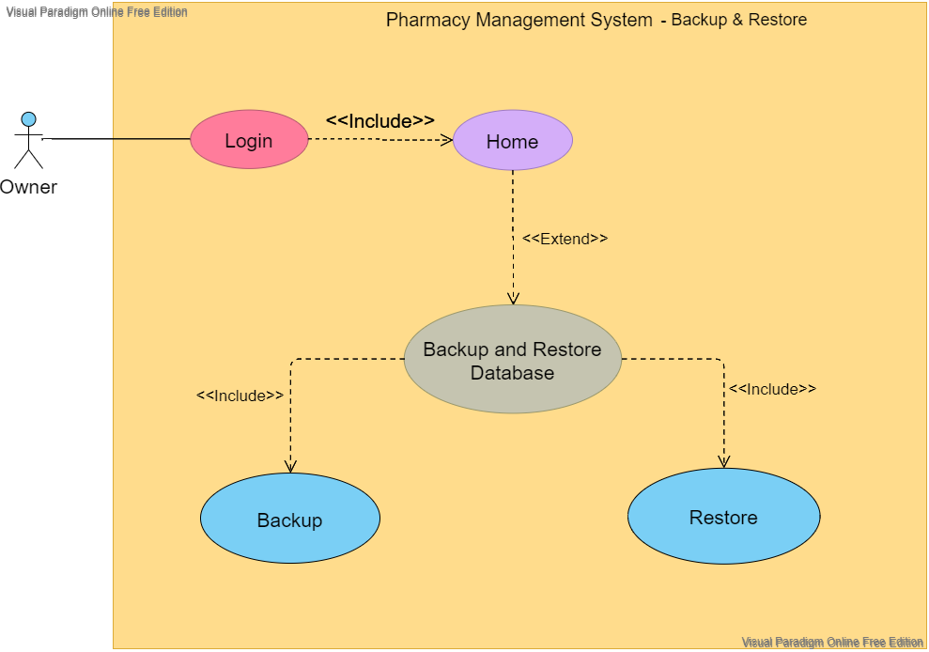

Here, only the owner has access to the pharmacy database. Having a copy (backup file) of the database is very important to ensure the safety of data. So, this PMS brings up the capability of getting the database backup process done much easily within seconds. Also in the other hand, this PMS provides the facility of restoring a backup file of the database and bring back the original database. Both these processes would simply consume just two clicks each. So, in order to carry out the process, the owner will have to log in proceed to the ‘Backup & Restore’ section which can be easily found on the side panel inside the software. Inside the particular section, the owner will be met with two options to restore and backup. Thereafter simply by selecting a location both the processes can be carried out.

1. Below diagram is to view and edit the customer details

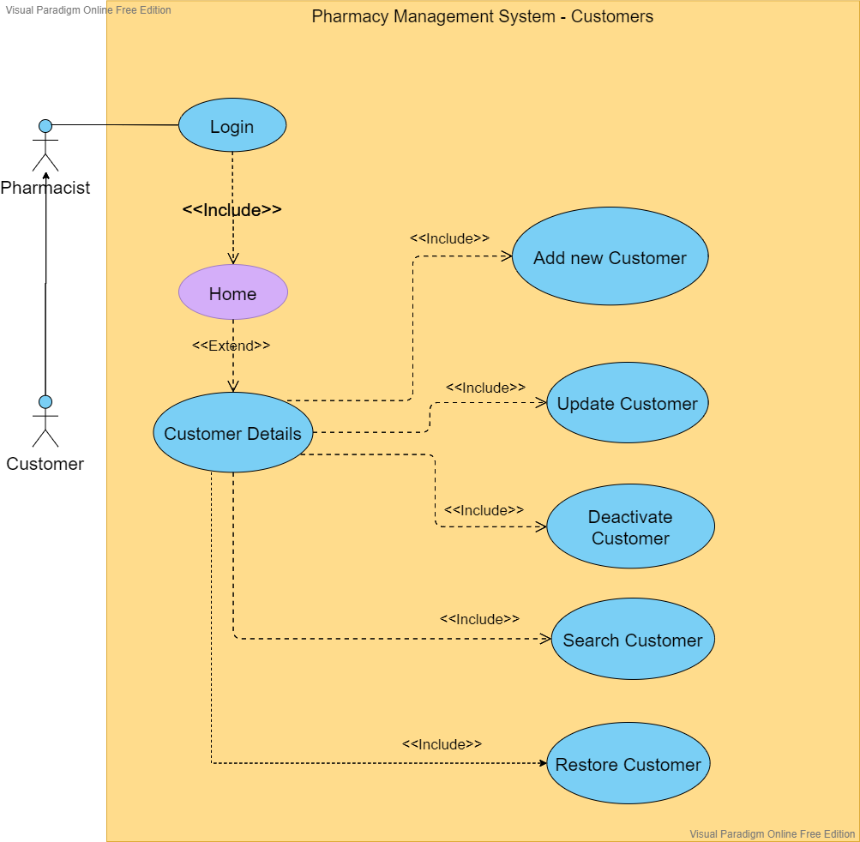

Both the owner and the pharmacist will have access to customer details. However, the pharmacist will be the one who deal with customer details. At the checkout, the customer can provide their details to the pharmacist if any discounts or further updates are needed. At the same time the pharmacist will have the possibility of adding a new customer to the database. And not only that, but also the PMS provides an easy way of updating the existing customer details. Searching a customer from the database can be done much easily within seconds which will show up all the stored details of that particular customer. And even a selected customer can be deactivated as well as restored immediately with just one click if needed.

1. Below diagram is to view and edit the admin details

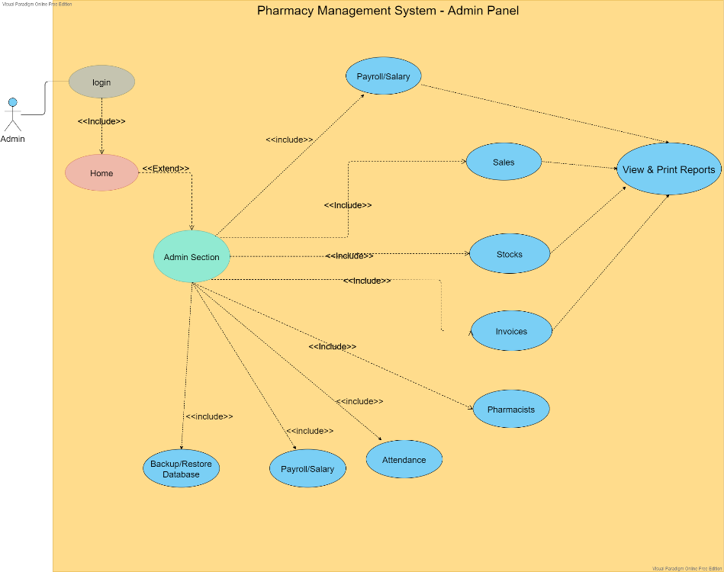

Here the admin area in the sense, the place where only the owner has access to. Admin panel consist of eight main sections. They are Sales, Profits, Stocks, Invoices, Pharmacists, Attendance, Payroll/salary, Backup & Restore. Admin can easily access each of these sections to carry out particular tasks.

1. Below diagram is to view and edit the payment details and generate invoices

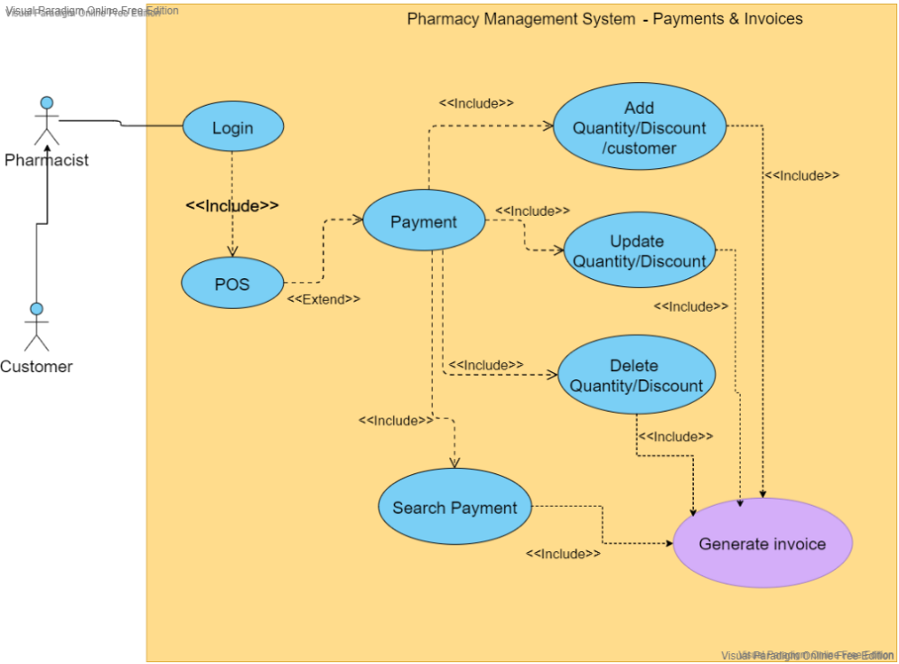

The above diagram shows how the payment process is done. Both the owner and the pharmacist will have access here. After login in, via the dashboard the payment section can be accessed easily. Inside the payment section, there are 5 main parts to add, update, delete and search payments and to generate invoices. Here, the processes of adding payments, updating payments and generating invoices will be mostly used by the pharmacist. Once the customer does a payment, the customer will be connecting with the pharmacist and pharmacist will be adding the payment to the database.

1. Below diagram is to view and edit the Product details

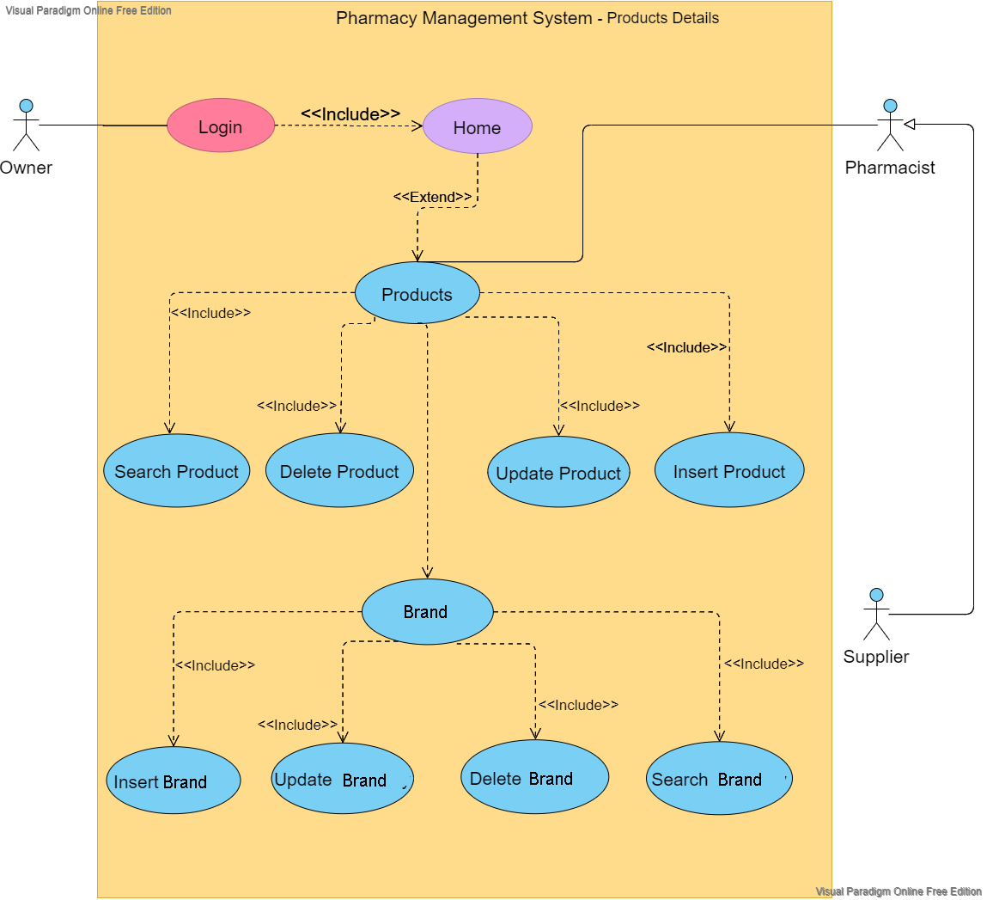

The products section can be accessed by both the owner and the pharmacist. Here, new products can be added, products can be searched immediately, existing products can be updated as well as deleted. Each and every product belongs to a certain category. So, this PMS helps to separately identify what those categories are and which products can be found under each category. Even a new category can be added, updated, searched and deleted as needed. In the process of adding a new product, the product details that need to be provided will be gathered from the supplier who will be connecting with the pharmacist.

1. Below diagram is to view and edit the staff details

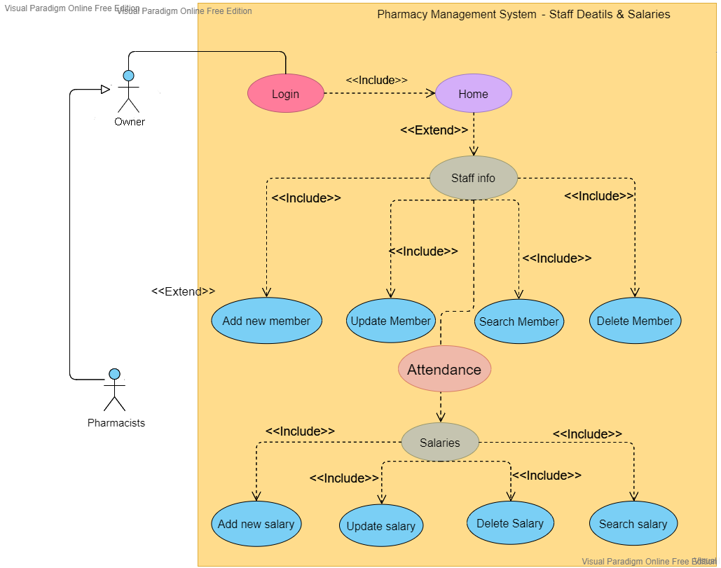

There are times when the staff has to be increased or decreased. For any instance regarding the staff, it can be easily managed using this PMS. If a new worker needs to be added to the pharmacy system, first the owner will be gathering the worker details and via the staff section, he can simply add a new member. Likewise, an existing worker can be searched, updated and deleted from the DB. At the same time the salaries of each and every worker can be calculated and managed as needed.

1. Below diagram is to view and edit the supplier details

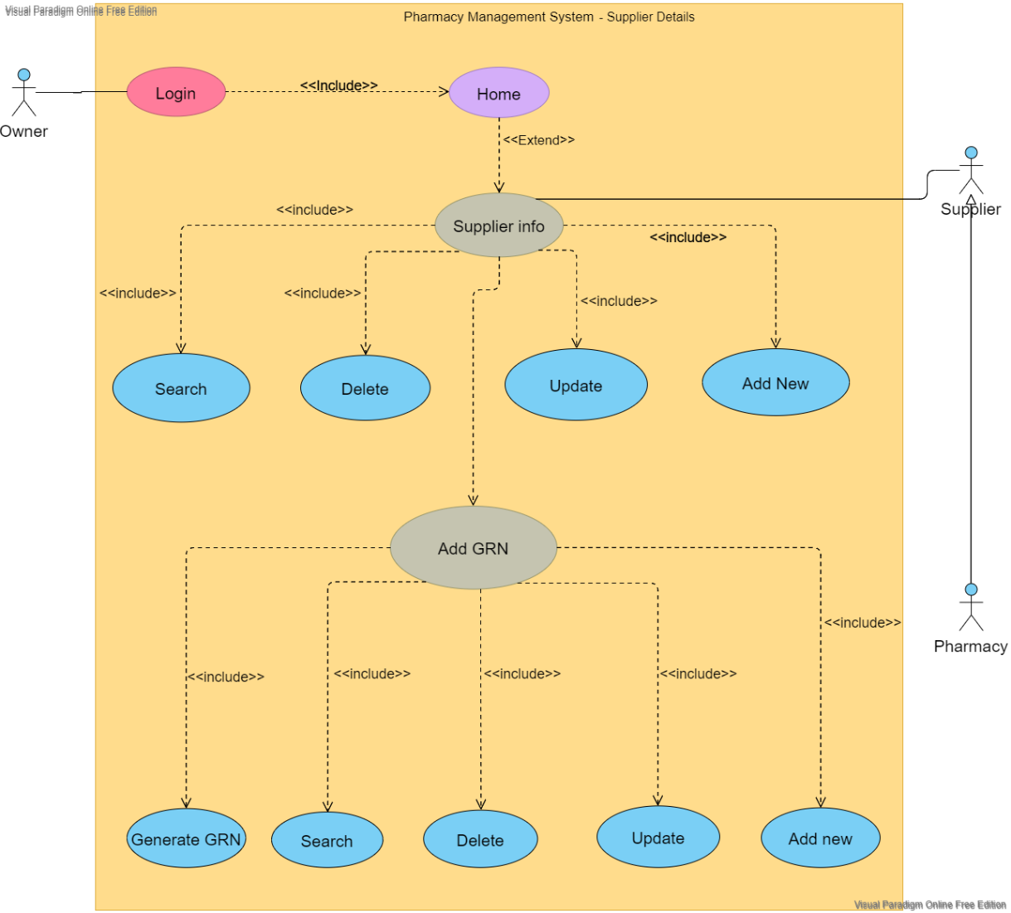

Once the supplier deals with the pharmacy, his/her details will be gathered and stored by the owner which then can be updated, searched and even deleted if needed. Here a two-way document, also known as GRN will be engaged as the evidence to confirm that the goods are being received at the correct destination. This GRN can also be updated, searched and deleted. Moreover, the PMS provides the ability to generate a new GRN.

1. Below diagram is to view and edit the stock details

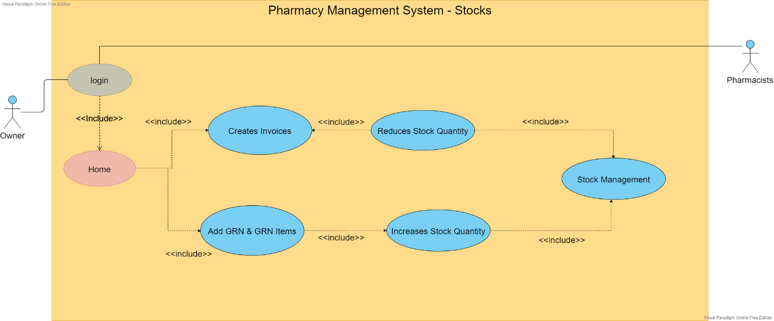

This is all about the stocks section in the pharmacy which can be accessed by both the owner and the pharmacist. Amount of stocks present can be easily viewed via this PMS. As usual these stocks can also be inserted, updated, searched and deleted. Stock handling is a process that need to be managed carefully as it’s an important unit in the pharmacy. It requires a plenty of paper works but with this PMS all those stocks can be handled easily without a great time consumption and free of errors.

## Class Diagrams

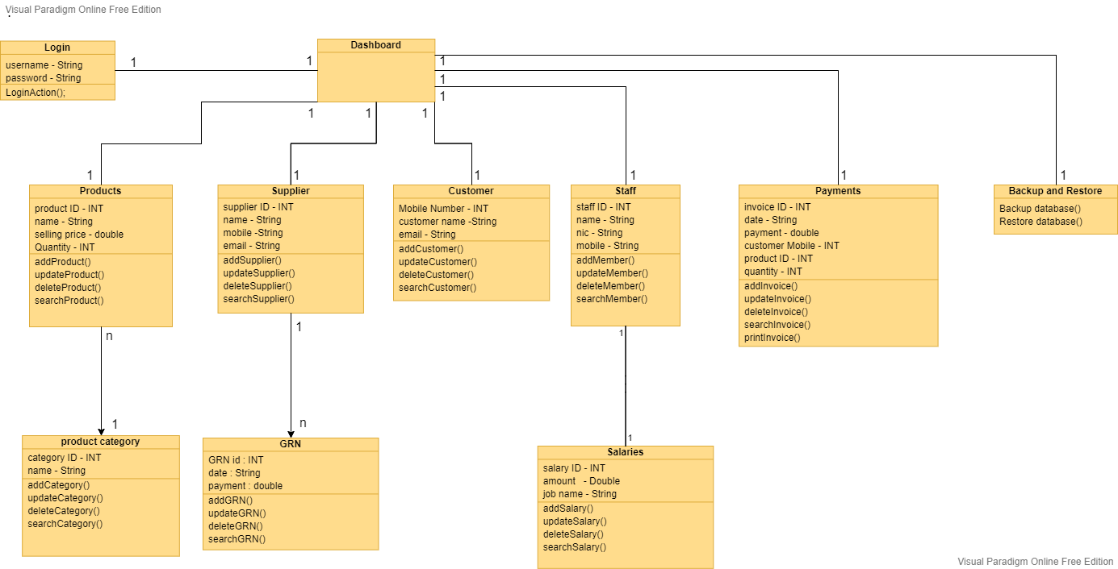

## Sequence Diagrams

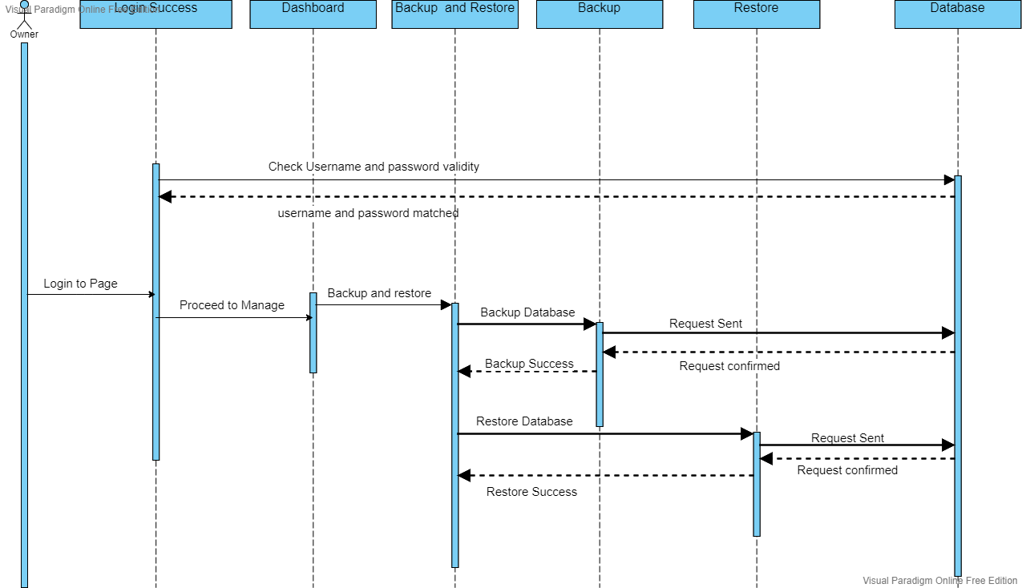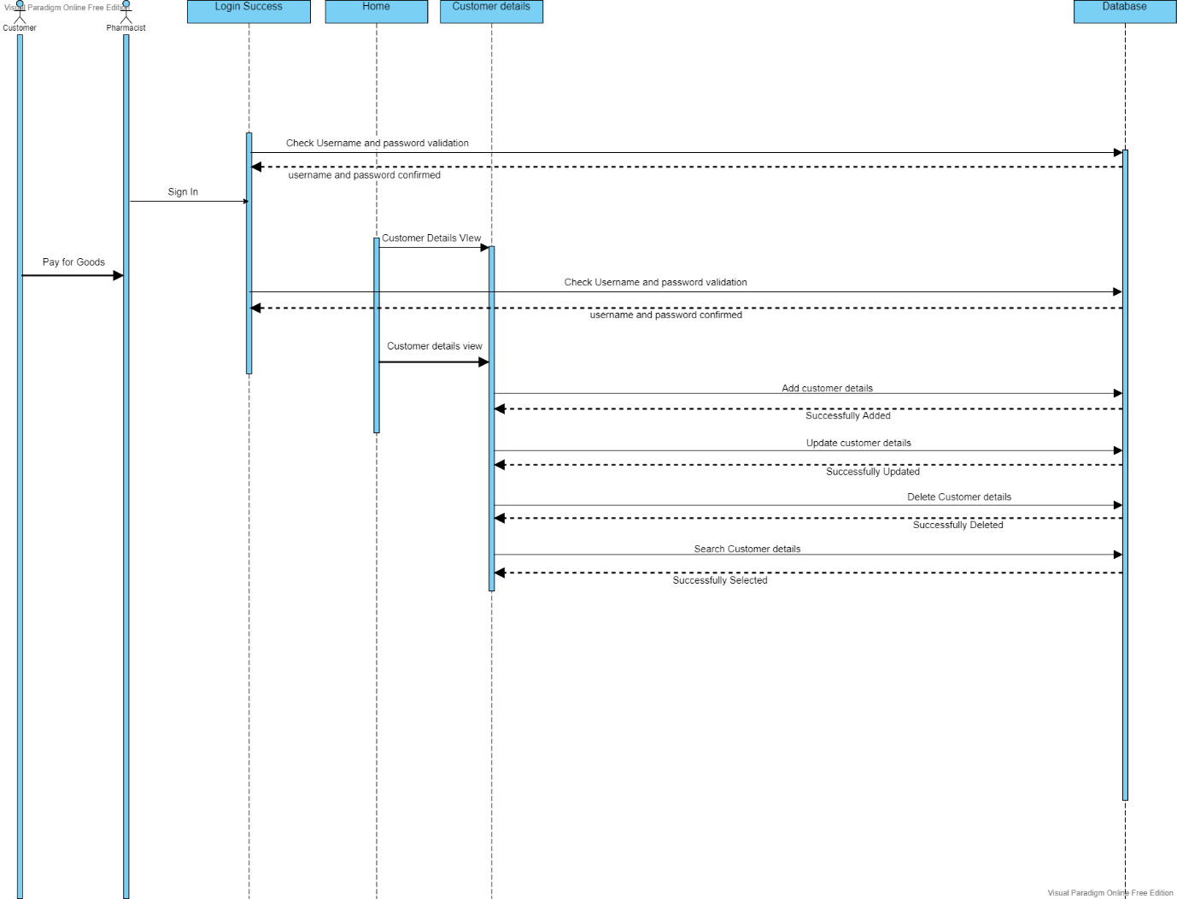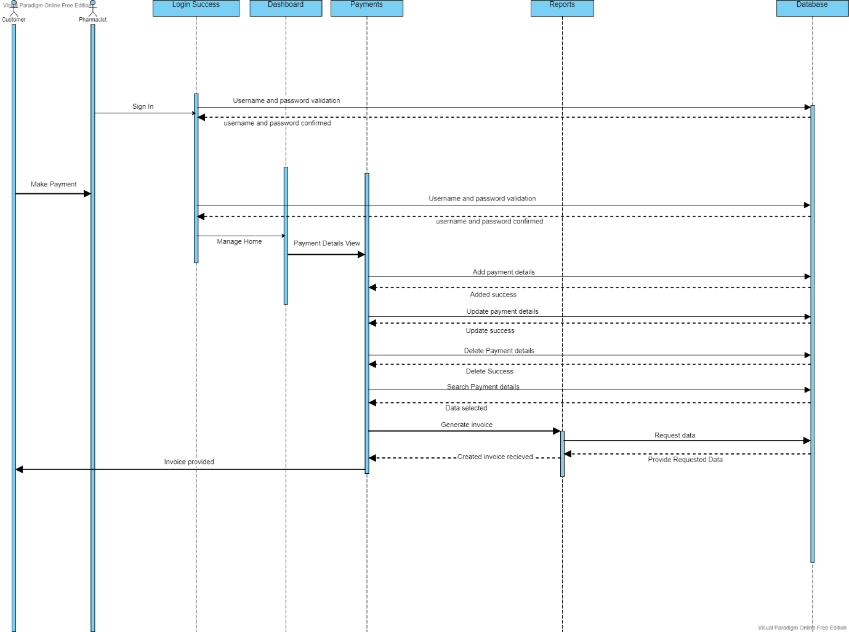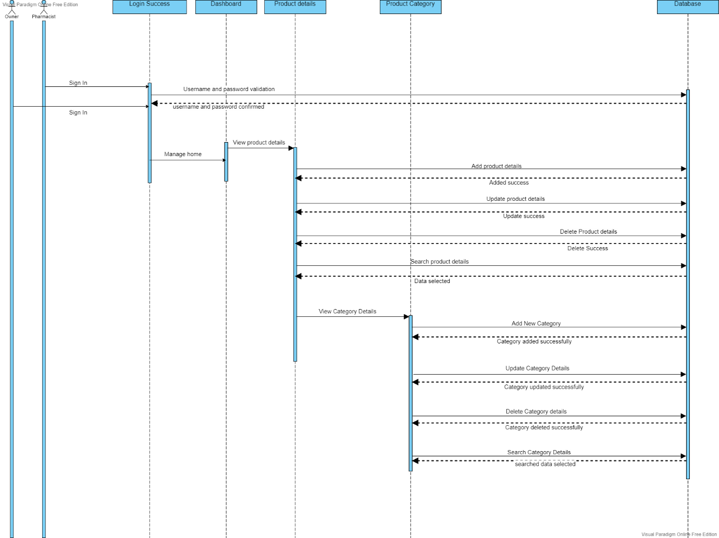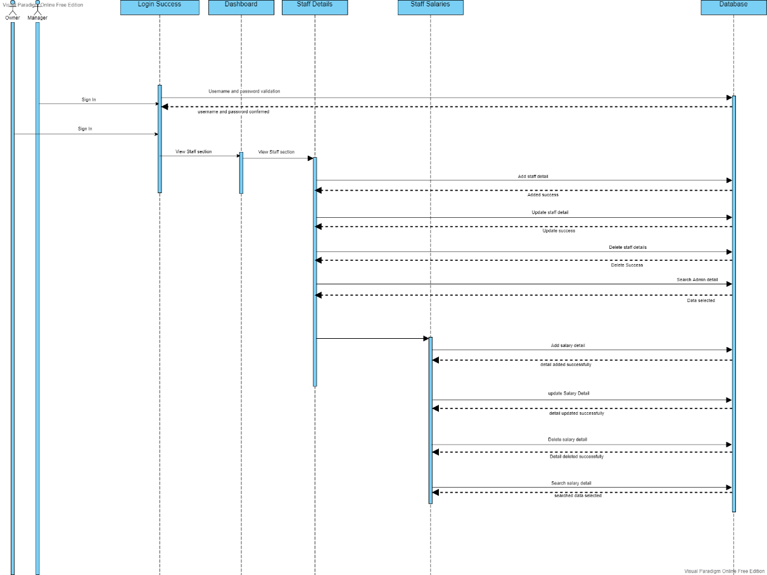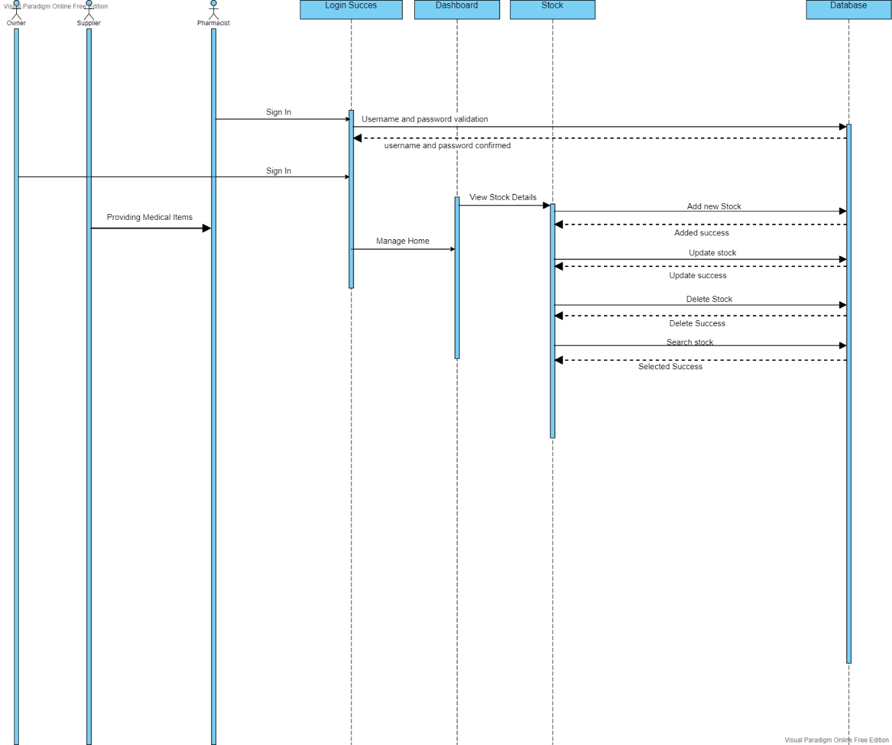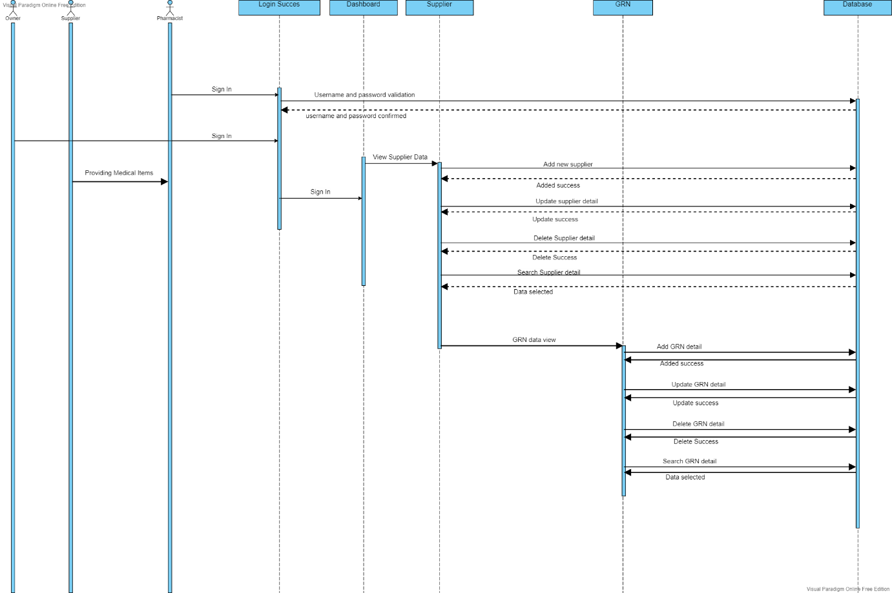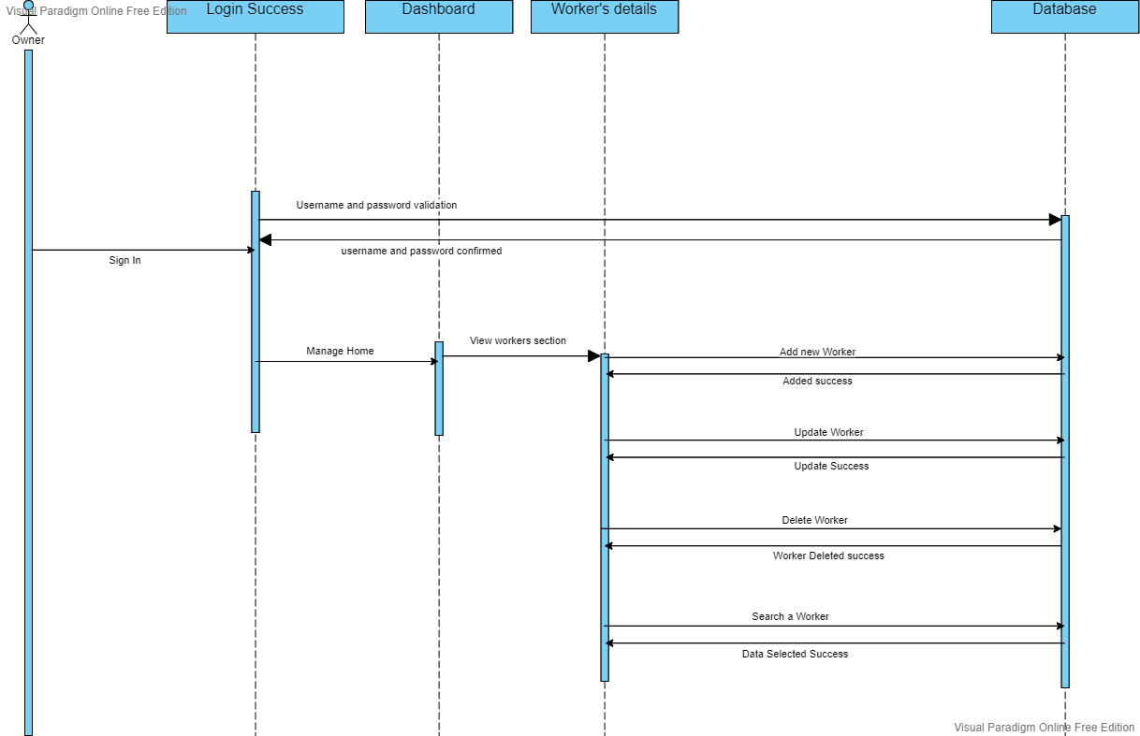

## ER Diagram

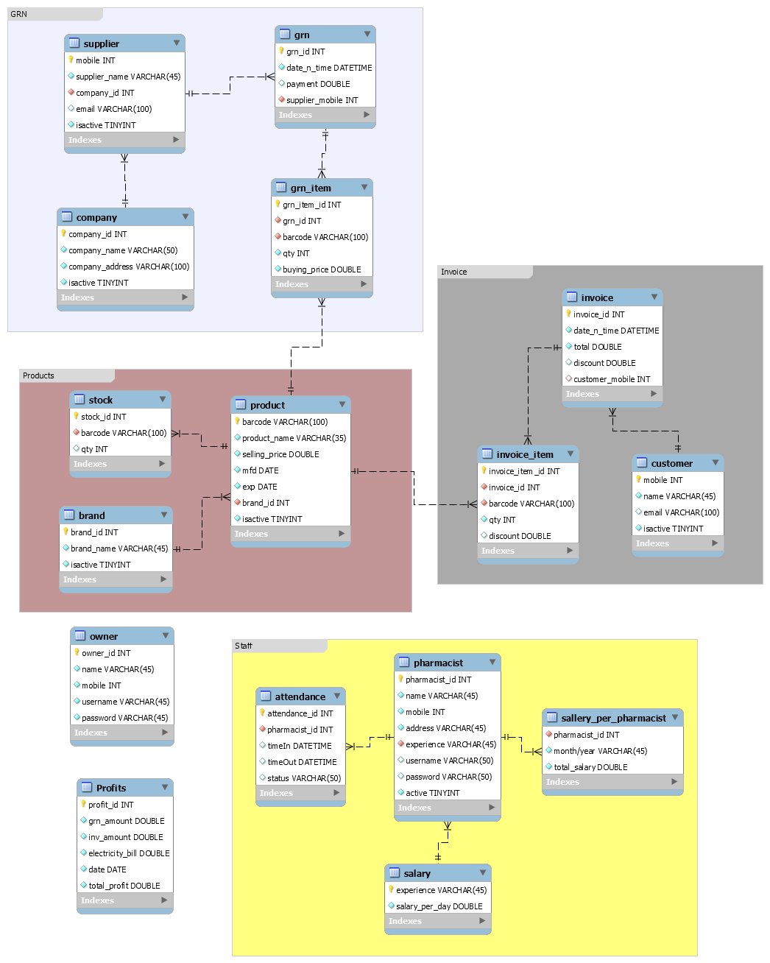

## Supplementary Requirements

There are four main facts here,

* Reliability

There should be no times when this PMS fails to deliver reliable and relevant search results. And it should be possible to complete the checkout process within five seconds

* Availability

Any software upgrade, patch, or fix should be performed without shutting down the application. To handle natural disasters, disaster recovery environments are needed

* Security

Using one-way hash algorithms, all user ID and other personal information should be encrypted in the database. It should be checked that all input fields don't contain SQL injection vulnerabilities. It should be ensured that input fields are sanitized before being sent to upstream systems. The password policy should outline how frequently a password should be changed, how many invalid attempts are allowed, etc.

* Maintainability

Extensibility and scalability of this PMS can be achieved through integration based on standards. A proper documentation should be present for every code artifact. It is advisable to thoroughly test the components of the code and ensure that test coverage is at least 95%

## User Interfaces

